

Padification srs

Date: 2017-06-09

Version: 0.9.6

McKenzie College SWTS2102

1. Revision History

|  |  |  |  |
| --- | --- | --- | --- |
| Date | Author | Version | Revision Notes |
| 2017-06-06 | William Gale | 0.1 | Heading layout for document. |
| 2017-06-06 | Elie Godbout | 0.2 | Added Sections 2 and 3 being; Conformance and Normative references. |
| 2017-06-06 | Zachary Blue | 0.3 | Added Scope and Definitions, Abbreviations and Acronyms. |
| 2017-06-07 | William Gale | 0.4 | Integrated Player Concept into Section 5.1, Updated Revision History Layout, and Title Page. |
| 2017-06-07 | Elie Godbout | 0.5 | Integrated the Game Overview Concept in section 5.1. |
| 2017-06-07 | Kyle Gunton | 0.6 | Integrated section 5.1.3 Dungeons Overview Concept in section 5.1. |
| 2017-06-07 | Zachary Blue | 0.7 | Integrated the Mailbox Overview Concept in section 5.1. |
| 2017-06-07 | Ryan Breau | 0.8 | Integrated the Friend Overview Concept in section 5.1. |
| 2017-06-07 | Elie Godbout | 0.8.1 | Updates to section 5.1.1 (Game overview) Android device requirements updated to 4.0 and higher, egg machine section now explains what types of in-game currency are required to operate the specific types off egg machines. |
| 2017-06-07 | William Gale | 0.8.2 | Updated section 5.1.2 (Player Overview) Improved Definition of Rank, Removed Balloons from figure, Added descriptive location in definitions. |
| 2017-06-08 | Ryan Breau | 0.8.3 | Updated section 5.1.5 (Friends): Improved explanations, changed figures. Integrated section 5.1.6 (Game Currency). |
| 2017-06-08 | William Gale | 0.8.4 | Integrated (Monster) as section 5.1.3 and sub sections for Experience and Leveling, Base Stats, And Bonus Stats. Modified TOC to display 4 headings deep. |
| 2017-06-08 | Elie Godbout | 0.8.5 | Integrated sub-sections of Monster to section 5.1.3. Sub-sections: Assists, Rarity, Monster ID, Monster name, Monster box, Monster book and Selling monsters. Added image to title page. |
| 2017-06-08 | Zachary Blue | 0.8.6 | Added more information to the mail section describing the functions and areas more, moved the mail images to the right side of the page, integrated section 5.1.8 Egg Machines, updated structure |
| 2017-06-08 | Kyle Gunton | 0.8.7 | Integrated updates to section 5.1.4 (Dungeons): updated order of dungeons. Changed in-dungeon content to Dungeon Entrance, Dungeon Gameplay and Dungeon Completion.  Integrated Evolution, Power-Up/Fusion, Attributes, Types, And Skills sections to 5.1.3 (Monster) |
| 2017-06-08 | William Gale | 0.9.0 | Modified Revision History to have more room for Notes. Applied Cosmetic changes to title page, Re-arranged sub sections of Monster, and moved Monster box and Monster book to Player Section. |
| 2017-06-08 | Ryan Breau | 0.9.1 | Fixed issues with sections 5.1.6 and 5.1.7. |
| 2017-06-08 | Elie Godbout | 0.9.2 | Updated section 5.1.1 (Game Overview): Formatting, moved rewards to Dungeon Completion. Updated section 5.1.3 (Monster): Added a description for Monsters, new descriptions for Monster Number ID, Monster name and Rarity, and Clarified Monster Assists. |
| 2017-06-09 | Kyle Gunton | 0.9.3 | Updated section 5.1.4 (Dungeon): Formatting, simplified descriptions for Shop and Machine and section 5.1.3 (Monster): Formatting, moved Power-Up Fusion and Evolutions below Monster stats. |
| 2017-06-09 | William Gale | 0.9.4 | Integrated Section Navigation as section 5.1.2, |
| 2017-06-09 | Elie Godbout | 0.9.5 | Integrated Multiplayer Mode in Section 5.1.8 (Dungeons) as section 5.1.8.9 |
| 2017-06-09 | Kyle Gunton | 0.9.6 | Integrated Teams in Section 5.1.4 (Monsters) as section 5.1.4.12  Moved Team Status from friends to teams |

1. Table of Contents

[I. Revision History 2](#_Toc484766848)

[II. Table of Contents 4](#_Toc484766849)

[III. List of Figures 6](#_Toc484766850)

[1 Scope 8](#_Toc484766851)

[2 Conformance 8](#_Toc484766852)

[2.1 Intended usage 8](#_Toc484766853)

[2.2 Conformance to Processes 8](#_Toc484766854)

[2.3 Conformance to information item content 8](#_Toc484766855)

[3 Normative References 8](#_Toc484766856)

[4 Terms, Definitions, and Abbreviated Terms 9](#_Toc484766857)

[4.1 Terms and Definitions 9](#_Toc484766858)

[4.2 Acronyms and Abbreviations 10](#_Toc484766859)

[5 Concepts 11](#_Toc484766860)

[5.1 Introduction 11](#_Toc484766861)

[5.1.1 Game overview 11](#_Toc484766862)

[5.1.2 Navigation 14](#_Toc484766863)

[5.1.2.1 Dungeon Navigation 14](#_Toc484766864)

[5.1.2.2 Monster Navigation 15](#_Toc484766865)

[5.1.2.3 Shop Navigation 15](#_Toc484766866)

[5.1.2.4 Machine Navigation 16](#_Toc484766867)

[5.1.2.5 Friend Navigation 16](#_Toc484766868)

[5.1.2.6 Others Navigation 17](#_Toc484766869)

[5.1.2.7 Quest Navigation 17](#_Toc484766870)

[5.1.3 Player 18](#_Toc484766871)

[5.1.4 Monster 19](#_Toc484766872)

[5.1.4.1 Monster Number ID 19](#_Toc484766873)

[5.1.4.2 Monster name 19](#_Toc484766874)

[5.1.4.3 Rarity 19](#_Toc484766875)

[5.1.4.4 Attribute 20](#_Toc484766876)

[5.1.4.5 Types 20](#_Toc484766877)

[5.1.4.6 Skills 20](#_Toc484766878)

[5.1.4.7 Monster Experience and Leveling 23](#_Toc484766879)

[5.1.4.8 Monster Stats 23](#_Toc484766880)

[5.1.4.9 Power-Up Fusion 24](#_Toc484766881)

[5.1.4.10 Evolution 25](#_Toc484766882)

[5.1.4.11 Assists 26](#_Toc484766883)

[5.1.4.12 Teams 27](#_Toc484766884)

[5.1.5 Dungeons 28](#_Toc484766885)

[5.1.5.1 Dungeon and Sub-Dungeons 29](#_Toc484766886)

[5.1.5.2 Normal Dungeons 29](#_Toc484766887)

[5.1.5.3 Technical Dungeons 29](#_Toc484766888)

[5.1.5.4 Special Dungeons 29](#_Toc484766889)

[5.1.5.5 Multiplayer Dungeons 30](#_Toc484766890)

[5.1.5.6 Ranking Dungeons 30](#_Toc484766891)

[5.1.5.7 Dungeon Entrance 30](#_Toc484766892)

[5.1.5.8 Dungeon Gameplay 31](#_Toc484766893)

[5.1.5.9 Multiplayer Mode 31](#_Toc484766894)

[5.1.5.10 Dungeon Completion 34](#_Toc484766895)

[5.1.6 Mail 34](#_Toc484766896)

[5.1.7 Friends 36](#_Toc484766897)

[5.1.7.1 Gaining Friends 36](#_Toc484766898)

[5.1.7.2 Friend Types 36](#_Toc484766899)

[5.1.7.3 Friend List 37](#_Toc484766900)

[5.1.8 Game Currency 38](#_Toc484766901)

[5.1.8.1 Coins 39](#_Toc484766902)

[5.1.8.2 Pal Points 39](#_Toc484766903)

[5.1.8.3 Monster Points 39](#_Toc484766904)

[5.1.8.4 Magic Stones 40](#_Toc484766905)

[5.1.9 Egg Machines 41](#_Toc484766906)

[5.1.9.1 Egg Machine Modifiers 41](#_Toc484766907)

[5.1.9.2 Egg Machine Costs 41](#_Toc484766908)

[5.1.9.3 Event Egg Machine Types 42](#_Toc484766909)

[5.2 Requirements Fundamentals 42](#_Toc484766910)

[5.3 Practical Considerations 42](#_Toc484766911)

[5.4 Requirement Information Items 42](#_Toc484766912)

[6 Processes 42](#_Toc484766913)

[6.1.1.1 Selling Monsters 42](#_Toc484766914)

[6.2 Requirements Processes 42](#_Toc484766915)

[6.3 Stakeholder Requirements Definition Process 42](#_Toc484766916)

[6.4 Requirements Analysis Process 42](#_Toc484766917)

[6.5 Requirements Engineering Activities in Other Technical Process 42](#_Toc484766918)

[6.6 Requirements Management 42](#_Toc484766919)

[7 Information Items 42](#_Toc484766920)

[8 Guidelines for Information Items 42](#_Toc484766921)

[9 Information Item Content 42](#_Toc484766922)

1. List of Figures

[Figure 1: Player information 11](file:///C:\Users\kyleg\PADification\Docs\SRS\Padification%20SRS.docx#_Toc484766799)

[Figure 2: Player ID search 11](file:///C:\Users\kyleg\PADification\Docs\SRS\Padification%20SRS.docx#_Toc484766800)

[Figure 3: Main menu bar 11](file:///C:\Users\kyleg\PADification\Docs\SRS\Padification%20SRS.docx#_Toc484766801)

[Figure 4: Monster box 12](file:///C:\Users\kyleg\PADification\Docs\SRS\Padification%20SRS.docx#_Toc484766802)

[Figure 5: Navigation Menu UML 14](#_Toc484766803)

[Figure 6: Dungeon Navigation UML 14](#_Toc484766804)

[Figure 7: Monster Navigation UML 15](#_Toc484766805)

[Figure 8: Shop Navigation UML 15](#_Toc484766806)

[Figure 9: Machine Navigation UML 16](#_Toc484766807)

[Figure 10: Friend Navigation UML 16](#_Toc484766808)

[Figure 11: Others Navigation UML 17](#_Toc484766809)

[Figure 12: Quest Navigation UML 17](#_Toc484766810)

[Figure 13: Player information Displayed in Information Banner 18](file:///C:\Users\kyleg\PADification\Docs\SRS\Padification%20SRS.docx#_Toc484766811)

[Figure 14: Player Name Change Menu 18](file:///C:\Users\kyleg\PADification\Docs\SRS\Padification%20SRS.docx#_Toc484766812)

[Figure 15: Monster box 19](file:///C:\Users\kyleg\PADification\Docs\SRS\Padification%20SRS.docx#_Toc484766813)

[Figure 16: Attributes & Types 20](file:///C:\Users\kyleg\PADification\Docs\SRS\Padification%20SRS.docx#_Toc484766814)

[Figure 17: Leader Skill & Active Skill 20](file:///C:\Users\kyleg\PADification\Docs\SRS\Padification%20SRS.docx#_Toc484766815)

[Figure 18: Awoken Skills 21](file:///C:\Users\kyleg\PADification\Docs\SRS\Padification%20SRS.docx#_Toc484766816)

[Figure 19: Latent Skills 22](file:///C:\Users\kyleg\PADification\Docs\SRS\Padification%20SRS.docx#_Toc484766817)

[Figure 20: Chart of Experience Curves 23](file:///C:\Users\kyleg\PADification\Docs\SRS\Padification%20SRS.docx#_Toc484766818)

[Figure 21: Monster Card 23](file:///C:\Users\kyleg\PADification\Docs\SRS\Padification%20SRS.docx#_Toc484766819)

[Figure 22: Monster Assist 24](file:///C:\Users\kyleg\PADification\Docs\SRS\Padification%20SRS.docx#_Toc484766820)

[Figure 23: Power-Up Fusion 24](file:///C:\Users\kyleg\PADification\Docs\SRS\Padification%20SRS.docx#_Toc484766821)

[Figure 24: Evolution 25](file:///C:\Users\kyleg\PADification\Docs\SRS\Padification%20SRS.docx#_Toc484766822)

[Figure 25: Monster info 26](file:///C:\Users\kyleg\PADification\Docs\SRS\Padification%20SRS.docx#_Toc484766823)

[Figure 26: Edit Team 27](file:///C:\Users\kyleg\PADification\Docs\SRS\Padification%20SRS.docx#_Toc484766824)

[Figure 27: Team Name Change 27](file:///C:\Users\kyleg\PADification\Docs\SRS\Padification%20SRS.docx#_Toc484766825)

[Figure 28: Awoken Badge 28](file:///C:\Users\kyleg\PADification\Docs\SRS\Padification%20SRS.docx#_Toc484766826)

[Figure 29 Dungeons Menu 28](file:///C:\Users\kyleg\PADification\Docs\SRS\Padification%20SRS.docx#_Toc484766827)

[Figure 30: Dungeon of Fire 29](file:///C:\Users\kyleg\PADification\Docs\SRS\Padification%20SRS.docx#_Toc484766828)

[Figure 31: Dungeon of Fire Sub-Dungeons 29](file:///C:\Users\kyleg\PADification\Docs\SRS\Padification%20SRS.docx#_Toc484766829)

[Figure 32: Special Dungeon Menu 29](file:///C:\Users\kyleg\PADification\Docs\SRS\Padification%20SRS.docx#_Toc484766830)

[Figure 33: Multiplayer Modes 30](file:///C:\Users\kyleg\PADification\Docs\SRS\Padification%20SRS.docx#_Toc484766831)

[Figure 34: Dungeon Entrance 30](file:///C:\Users\kyleg\PADification\Docs\SRS\Padification%20SRS.docx#_Toc484766832)

[Figure 35: Input Room ID 31](file:///C:\Users\kyleg\PADification\Docs\SRS\Padification%20SRS.docx#_Toc484766833)

[Figure 36: 3-Player dungeon menu 32](file:///C:\Users\kyleg\PADification\Docs\SRS\Padification%20SRS.docx#_Toc484766834)

[Figure 37: Created Room 33](file:///C:\Users\kyleg\PADification\Docs\SRS\Padification%20SRS.docx#_Toc484766835)

[Figure 38 Mailbox 35](file:///C:\Users\kyleg\PADification\Docs\SRS\Padification%20SRS.docx#_Toc484766836)

[Figure 39 Piece of mail 35](file:///C:\Users\kyleg\PADification\Docs\SRS\Padification%20SRS.docx#_Toc484766837)

[Figure 40 Dungeon Mail 35](file:///C:\Users\kyleg\PADification\Docs\SRS\Padification%20SRS.docx#_Toc484766838)

[Figure 41 Mail Sorting 36](file:///C:\Users\kyleg\PADification\Docs\SRS\Padification%20SRS.docx#_Toc484766839)

[Figure 42 Best Friend 36](file:///C:\Users\kyleg\PADification\Docs\SRS\Padification%20SRS.docx#_Toc484766840)

[Figure 43 Mail Expiry 36](file:///C:\Users\kyleg\PADification\Docs\SRS\Padification%20SRS.docx#_Toc484766841)

[Figure 44 Select a Helper Screen 37](file:///C:\Users\kyleg\PADification\Docs\SRS\Padification%20SRS.docx#_Toc484766842)

[Figure 46 Friend List Screen 38](file:///C:\Users\kyleg\PADification\Docs\SRS\Padification%20SRS.docx#_Toc484766843)

[Figure 47: Friend Options, Not Favorited(Left), Favourited(Right) 38](file:///C:\Users\kyleg\PADification\Docs\SRS\Padification%20SRS.docx#_Toc484766844)

[Figure 48: Magic Stones and Coins (Right Side) 39](file:///C:\Users\kyleg\PADification\Docs\SRS\Padification%20SRS.docx#_Toc484766845)

[Figure 49: Pal Points 39](file:///C:\Users\kyleg\PADification\Docs\SRS\Padification%20SRS.docx#_Toc484766846)

[Figure 50: Monster Points 39](file:///C:\Users\kyleg\PADification\Docs\SRS\Padification%20SRS.docx#_Toc484766847)

# Scope

Our project PADification will be designed and produced through the following processes: evolving a monster, beating a dungeon, leveling up a monster, selling a monster, and more. Through those processes we will produce a database that contains all the information pertaining to monsters found within the North American version of Gungho’s Puzzle and Dragons mobile videogame. Using that database, we will create a program for the purpose of logging and maintaining a user’s input monsters as well as allow users to search for monsters and simulate team builds. PADification will also allow users to add a wishlist for monsters that they either need or would like to collect in the future.

# Conformance

## Intended usage

The intention of conformance for this SRS document is to help stakeholders understand where the data and information the group has gathered come from and under what format, scope and decree they will follow.

## Conformance to Processes

* The PADification final product aims simulate processes found in the Puzzles and dragons mobile video-game developed by Gungho online entertainment Inc. The main process is as follows:
  + Creation, updates and deletion of teams
    - Leader monster
    - Sub monsters
    - Team name
    - Badge equipped
* The idea behind this is to allow players of puzzles and dragons from around the world to share the teams as well as monsters they own to other players. Something that puzzles and dragons does not permit at the current time.

## Conformance to information item content

* The PADification final product gathers all its information from the puzzles and dragons mobile video-game developed by Gungho online entertainment Inc. as well as from third party website: <http://puzzledragonx.com/com>
* If information found within puzzledragonsx.com should ever prove unreliable, unsure and/or faulty, it is required to have the issue resolved by identifying it within puzzles and dragons.
* Information regarding instances of player information and instances of specific monsters are found within puzzles and dragons by way of the player’s account information.

# Normative References

ISO/IEC/IEEE 29148-2011 SRS International Standard Document

<https://webcache.googleusercontent.com/search?q=cache:OQfOP0Z_vMQJ:https://edisciplinas.usp.br/pluginfile.php/1077344/mod_folder/content/0/iso-iec-ieee-29148-2011.pdf%3Fforcedownload%3D1+&cd=3&hl=en&ct=clnk&gl=ca>

Puzzle and Dragons X

<http://www.puzzledragonx.com/>

“Puzzle and Dragons” game

<https://itunes.apple.com/ca/app/puzzle-dragons-english/id563474464?mt=8>

<https://play.google.com/store/apps/details?id=jp.gungho.padEN&hl=en>

<http://www.gunghoonline.com/games/puzzle-dragons/>

# Terms, Definitions, and Abbreviated Terms

## Terms and Definitions

* + (Plus) stats – Bonus stats applied to HP, ATK, and RCV. Up to 99 + stats can be granted to each stat for a monster for a total of 297. A bonus of +# times 10 is granted to HP, +# times 5 for ATK, and +# times 3 for RCV.
* Active Skill – An modifier belonging to monsters that can be used in dungeons to modify the board, the player’s team or the enemies.
* Assist Monsters – Monsters can be assigned to other monsters. The assisted monster gains the active skill of the assisting monster as well as a possible stat boost while the assisting monster can no longer be brought into dungeons or sold. Not all monsters can be assists.
* Attack – A monster’s statistic that determines the base amount of damage a monster can deal.
* Attribute – A property of a monster that determines the type of damage a monster will deal. A monster can currently have up to two (minimum of one) of five attributes consisting of Fire, Water, Wood, Light, and Dark.
* Awoken Skill – A passive modifier granted to a monster.
* Awoken Skills – A passive modifier a monster may have. All monsters with the same Monster ID have the same Awoken Skills. A monster may have zero to nine of them.
* Database - A structured set of data held in a computer, especially one that is accessible in various ways.
* Dungeon – A section within PAD that allows the user to obtain experience, coins, magic stones, and monsters.
* Egg machine – A feature that allows a user to use magic stones or pal points to procure a random monster from a pool of monsters.
* Evolution - Monsters can evolve/devolve into other monsters when certain conditions are met.
* Health Points – A monster’s statistic that determines how much damage a monster can take before a player dies.
* Latent Awoken Skills - A type of awoken skill that you assign to a monster.
* Latent skills – A passive modifier that can be assigned to monsters through power-up/fusion. Up to a max of 6 can be added to a single monster.
* Leader Skill - An in-dungeon modifier granted to the player based on the leader monster. Not all monsters have one.
* Magic stones – A in-game currency within that can be used to restoring stamina, buying eggs from the egg machine, and allowing the user to continue a dungeon upon death (where applicable). Purchasable with real money.
* Mail System – An in-game communications system through which players can communicate with other players and admin. Monsters and currency are able to be obtained through the mail system.
* Monster – Characters that can be obtained within the game through dungeons, mail, and egg machines.
* Monster Assist – A monster assigned to another monster to offer a second active skill and slight stat boost.
* Monster Experience – An indicator of a monster’s current progression towards it’s maximum potential.
* Monster ID – All unique integer identifier assigned to each monster.
* Monster Level – A statistic of a monster that acts as a modifier based on a monster’s experience.
* Monster Name - All monsters have a name that are unique (if only by case).
* Monster Types - Monsters have 1-3 types. There are currently 12 different types a monster may have.
* Pal points – An in-game currency collected from helping friends in dungeons, using friends’ monsters in dungeons, and logging in each day that is used to purchase pulls from the Pal Egg machine.
* Puzzle and Dragons – A game involving monster collection and team creation required to defeat more difficult Dungeons.
* Rank – a player grading system that determines the amount of stamina, friends, features the Player can have.
* Rarity - An indicator of how common or uncommon a monster is.
* Recovery – A monster’s statistic that determines the base amount of health a monster will heal for the team.
* Stamina – An integer value that determines a player’s access to a dungeon. Entering a dungeon will take a specified amount of stamina from the player’s current stamina count. Stamina recharges over time up or upon ranking up, to the maximum amount a player can hold. The amount a player can hold is based on rank.
* Type – A classification of a monster. A monster can currently have up to three (minimum of one) of (currently) twelve types.

## Acronyms and Abbreviations

* PAD – Puzzles and Dragons
* HP – Health Points
* ATK – Attack
* RCV – Recovery
* RDBMS – Remote Database Management service
* DB – Database
* NA – North America

# Concepts

## Introduction

### Game overview

Puzzles and Dragons is a video-game developed by Gungho entertainment Inc. for mobile platforms. The objective of this Puzzles and Dragons is to collect monsters by way of various methods, create teams with these monsters in order to complete dungeons which grants the player with various rewards such as new monsters and in-game currency. Clearing dungeons also push a player’s account by way of experience points. This effectively increases a player’s ability to access more advanced parts of the video-game. The rewards obtained can be used to enhance their monsters and be used to accomplish other tasks.

Compatible mobile devices:

* Apple IOS 6.0 and higher
* Android 4.0 and higher
* Kindle
  + Fire (2nd generation)
  + Kindle HP
  + Kindle Fire HDX

**Player account**

Puzzles and Dragons requires the player to create an account in order to use the application. Once the account is created or when signing in, A player’s account will contain the player’s personal information and account information such as currency, rank, monsters, cleared dungeons, etc.

Figure 1: Player information

* Rank
* Current & Max Stamina
* Currency
  + Magic stones
  + Coins
  + Pal points
  + Monster points

Figure 2: Player ID search

* Attribute
* Player ID

**Menu bar**

Puzzles and Dragons contains an ever-present menu system located at the bottom of the game window. (except when in gameplay)

Figure 3: Main menu bar

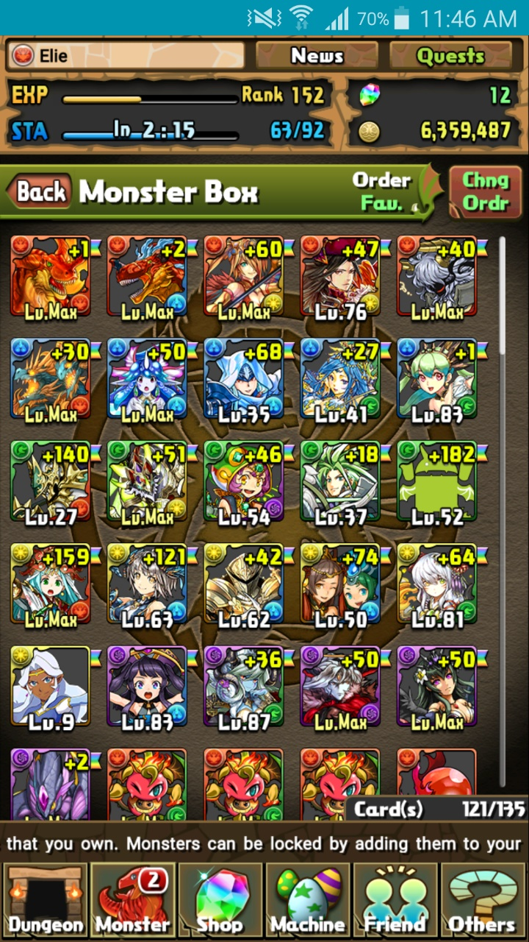 **Monster**

From the Monster option on the main menu, a player has access to a list of monsters they’ve acquired while playing known as the monster box. Within this section, a player can select a number of additional options such as:

* Viewing their monster collection via Monster Box
* Sell Monsters
* Manage Assists
* Evolve or Ultimate-evolve monsters
* Enhance monsters via level-up Fusion
* Edit teams for use in dungeons

**Dungeons**

From the Dungeons option, players can access the main gameplay of Puzzles and Dragons known as dungeons. There exist many types of dungeons:

* Normal
* Technical
* Special
* Multiplayer
* Ranking
* Coin dungeons

**Shop**

Figure 4: Monster box

From the Shop option, players have access to shops in Puzzles and Dragons. Here, a player can spend the in-game currency they’ve acquired to purchase in-game goods or enhance their account. Microtransactions can also be performed if a player so chooses.

* Magic stone shop (microtransactions)
* Monster shop
* Coin dungeons
* Refill stamina
* Expand monster box
* Expand friend list capacity

**Machine**

From the machine option, a player has access to a lottery style monster generator known in-game as egg machines. These allow players to spend in-game currency to obtain randomly selected monsters.

* Pal egg machine
* Rare egg machine
* Special event egg machine (**Note:** This option is not always available)

**Friend**

From the Friend option, players may interact with other players by sending invitations to others and register them as friends by sharing player IDs. Players can then choose to send messages to their friends and best friends.

* View registered friends via Friend List
* Search for players and view your player ID in ID search
* View messages and notifications in Mail / Invites
* Send Mail is used to send messages specifically to registered friends

**Other**

From the Others option, players have access to a wide range of options concerning the functions of the application, links to external sources, services about the game, information about Gungho, options to change certain settings, etc.

* Links
* Monster Book
* Options
* Help
* User info
* Support
* Device change
* Terms of service etc.
* Data Installation
* Screen Display Settings
* Return to Title Screen

**Quests**

Found on the top right corner, players have access to quests. These offer rewards to players once specific conditions are met. Each quest is classified within categories and state the specific request needed to obtain the reward associated to a given quest.

* Degree of difficulty
* Descended
* Maniacs

**News**

On the top corner of the window, next to the quests option, players have access to a news section to view the latest information on the daily activities of Puzzles and Dragons and/or any changes and updates done to the application. All these are composed by Gungho.

### Navigation

Puzzles and Dragons uses a Simple Category Style Navigation breaking up Into Individual Subjects. Starting the Game Brings you to the Title Screen which allows you to start the game or access Data Restoration. Once inside the game the categories are listed at the bottom excluding News and Quest, which are located in the top right of the screen. The Navigation Menu is accessible through the game, except while in a dungeon, Pulling and Egg machine, or Composing a Message.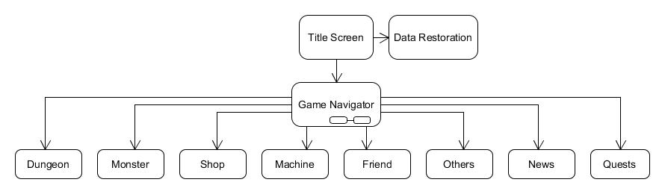

Figure 5: Navigation Menu UML

#### Dungeon Navigation

Following the same Category Style, once in the Dungeon Section you are presented with the Categories of dungeons available, and also Multiplayer mode. Selecting a Dungeon category brings you to the Dungeon Select Screen, after selecting a dungeon you are then presented with the sub dungeons list for that dungeon. Before entering the dungeon, you are given the chance to select a helper, or activate Challenge mode at the bottom of the list of helpers.

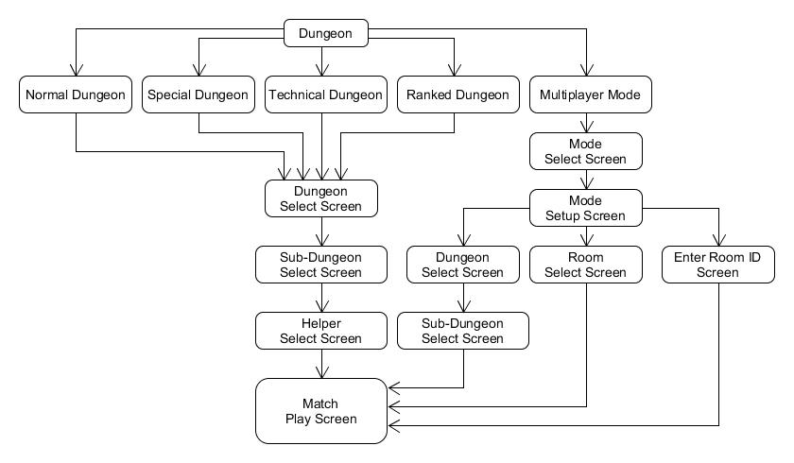

Figure 6: Dungeon Navigation UML

#### Monster Navigation

The monster Menu allows you to manage your Monster and Teams, from here you can Power-Up Fusion, Evolve, manage you Assistants, and sell your monsters. Or you may just look at them from the Monster Box.

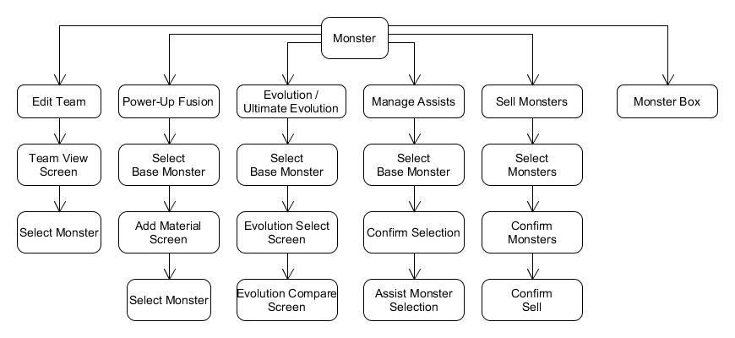

Figure 7: Monster Navigation UML

#### Shop Navigation

The Shop Menu Allows you to access the shops within puzzles and dragons, The Magic Stone shop requires you to verify you are of age as its purchases require real currency.

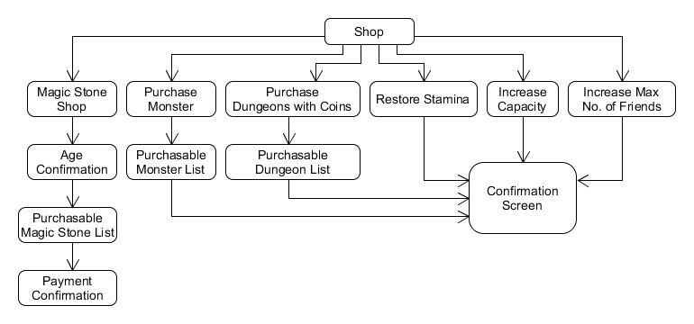

Figure 8: Shop Navigation UML

#### Machine Navigation

The Machine Menu has few Options, it will list available machines, if you have the currency for the machine, you select the machine and agree with the confirmation. The details menus will show you information on the available machines.

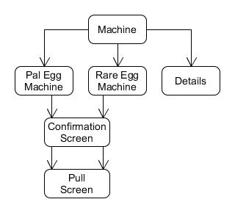

Figure 9: Machine Navigation UML

#### Friend Navigation

The Friend Menu Allows you to View your Friends with Friend lists, Add Friends by ID With ID Search, View your notifications and Mail in the Mail / Invites, And to send Mail to players on your friend list.

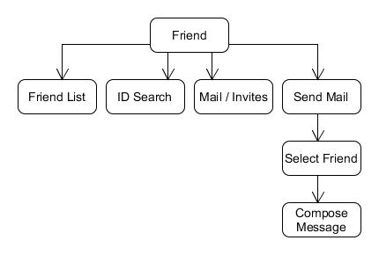

Figure 10: Friend Navigation UML

#### Others Navigation

The Others Menu has Support, Settings, Help, User info, and the Legal information. You can change the Settings for Screen ratio in Screen Display Settings, Graphics and Sound in Options, And player name and user settings in the User Info menu. The Help, Support, and Links menus offer Information on gameplay, and resources outside the game.

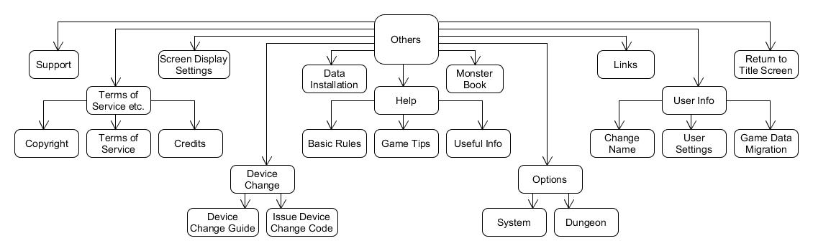

Figure 11: Others Navigation UML

#### Quest Navigation

The Quest Menu lists the Categories of Quests in the Game, once Accessed your are displayed a list of Quest, selecting a Quest displays the List of objectives for the Quest.

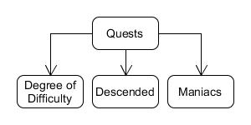

Figure 12: Quest Navigation UML

### Player

The Representation of the entity playing Puzzles and Dragons, it holds all information related to the specific user, it consists of the following Elements:



Figure 13: Player information Displayed in Information Banner



Figure 14: Player Name Change Menu

* Player ID - A Unique 9 Digit identifier of the Player, Used for account identification, and migration / recovery. Located at the top left corner of start screen.
* Name - Chosen by the Player; Displayed to other Players, but not used for account identification as it is not unique and changeable at any time. Displayed in top left corner of the information Banner.
* Experience - Obtained through completion of dungeons. It is used to determine a player’s Rank. Displayed in the top left dark area of the information Banner as EXP.
* Rank - An integer value determined by your current exp. Gaining Rank restores your Stamina, as well as granting an increase to Max Team Cost, Max Stamina, and Max Friends at predetermined Ranks. Displayed to the Right of the EXP bar.
* Stamina - An integer value based on level that regenerates 1 every 3 mins, fills on Rank up or with a magic stone Purchase, spent when entering Dungeons. Displayed in the top left Dark area in the information banner as STA, it is the left numeric value on the right side of the blue stamina bar.
* Max Stamina - This is the maximum amount of Stamina a Player can store. It is displayed on the right side of the Stamina value.
* Coins - An in-Game Currency, Used in power-up fusion, and Dungeon Purchases. It is displayed in the bottom of the right Dark area of the information Banner.
* Magic Stones - An in-Game currency gained from first time dungeon completion, real money purchase, promotional events. Used for Rare Egg Machine, Restoring Stamina, fully heal team on lose, increasing capacity, and increasing max friends past 50. Displayed in the top of the right Dark area of the information Banner.
* Monster points - An in-Game currency used to purchase monsters. Value is viewable at the Monster Point Shop.
* Pal Points - An in-Game currency earned from using a Helper during Dungeons. Value is Viewable by Selecting the Pal Point Machine.
* Quests - A set of Goals to complete which grant various Rewards, In the form of Dungeons, Badges, Monsters and Currency.
* Monster Box - The monster box is an area within Puzzles and Dragons where a player may view their collection of acquired monsters from playing the game to obtaining them via gifts. A player’s initial monster box is able to hold a maximum of 100 monsters. The box’s maximum range can be expanded however through the shop option under “Increase Capacity”.



Figure 15: Monster box

* Monster Book - The monster book is an area with Puzzles and Dragons where a player may view a list of all monsters available in the game. This list will only showcase the monsters a player has either obtained or have encountered in dungeons. Monster whom have not been encountered are simply represented by a grey question mark with the monster ID listed.
* Starting Attribute - Selected by starting monster picked, Places icon next to name. Determines player’s time group as well as their ID. Located to the Left of players Name
* Teams - Groups of 1-5 monsters picked from the players Monster Collection, used to play dungeons.
* Friends - A collection of players friended by the Player, Allows use of friend leaders as helpers.

### Monster

Monsters are characters found in Puzzles and Dragons. They are the main attraction of the game and they serve as both a player’s protagonists as well as antagonists. Players can collect, enhance and evolve monsters. This will, in turn, increase their chances of survival when confronting the monsters found in dungeons. There exist enumerable monsters with their own functions and properties within Puzzles and Dragons.

#### Monster Number ID

Each monster is uniquely represented by an Integer value known as their monster Number ID. This helps to differentiate each monster. It can also help indicate how many monsters have been added to the game.

#### Monster name

Alphanumeric identifier associated to monsters in order to help players find any specific monster from the multitude of other monsters found within the game.

#### Rarity

Each monster has a value represented by stars. This helps players determines how valuable a monster can be and how common it may be.

#### Attribute

Attributes are the property of a monster that determines the type of damage a monster will deal in a dungeon. A monster can currently have up to two (minimum of one) of five attributes consisting of:

* Fire
* Water
* Wood
* Light
* Dark

#### Types

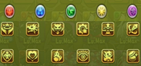A classification of a monster. A monster can currently have up to three (minimum of one) of (currently) twelve types.

* God
* Devil
* Machine
* Healer
* Dragon

Figure 16: Attributes & Types

* Physical
* Attacker
* Balanced
* Evo Material
* Enhance Material
* Awaken Material
* Redeemable Material

#### Skills

Figure 17: Leader Skill & Active Skill



**Skill:**

A modifier belonging to monsters that can be used in dungeons to modify the board, the player’s team or the enemies. Active skills are used within dungeons by the player. They have three main pieces to them. The effect, the level of the skill, and its cooldown.

The effect is a modifier that may change the board, the players monsters, or the enemy monsters.

The level is the current level the skill is at. Leveling up a skill will reduce its cooldown by one turn. Skills have a maximum level.

The cooldown is the number of turns a player must take within a dungeon before they are able to use the active skill.

**Leader Skill:**

A passive in-dungeon modifier granted to the player based on the leader monster. This may modify the board, the player’s team or the enemies. Also, upon meeting certain requirements, additional bonuses will be added during dungeon play. Not all monsters have a leader skill. Effects from multiple leader skills multiply.

**Awoken Skill:**

Awoken skills are passive skills that are activated upon fulfilling certain requirements within a dungeon.

Monster may have no awoken skills or several.

Awoken skills are not initially active.

* Attacker Killer
* Auto-Recover

Figure 18: Awoken Skills

* Awaken Material Killer
* Balanced Killer
* Devil Killer
* Dragon Killer
* Enhance Material Killer
* Enhanced Attack
* Enhanced Combo
* Enhanced Dark Att.
* Enhanced Dark Orbs
* Enhanced Fire Att.
* Enhanced Fire Orbs
* Enhanced Heal
* Enhanced Heal Orbs
* Enhanced HP
* Enhanced Light Att.
* Enhanced Light Orbs
* Enhanced Water Att.
* Enhanced Water Orbs
* Enhanced Wood Att.
* Enhanced Wood Orbs
* Evo Material Killer
* Extend Time
* God Killer
* Guard Break
* Healer Killer
* Machine Killer
* Multi Boost
* Physical Killer
* Recover Bind
* Redeemable Material Killer
* Reduce Dark Damage
* Reduce Fire Damage
* Reduce Light Damage
* Reduce Water Damage
* Reduce Wood Damage
* Resistance-Bind
* Resistance-Dark
* Resistance-Jammers
* Resistance-Poison
* Resistance-Skill Bind
* Skill Boost
* Two-Pronged Attack

**Latent Awoken Skill:**

Latent Awoken skills are the same as awoken skills, however monsters may only (currently) have a maximum of six. Unlike Awoken Skills, Latent skills are added to a monster by the player through Power-Up Fusion. Not all monsters are able to use all latent skills.

Figure 19: Latent Skills

|  |
| --- |
| * Attacker Killer |
| * Auto-Heal |
| * Balanced Killer |
| * Dark Damage Reduction |
| * Devil Killer |
| * Dragon Killer |
| * Extend Move Time |
| * Fire Damage Reduction |
| * God Killer |
| * Healer Killer |
| * Improve All Stats |
| * Improved Attack |
| * Improved Healing |
| * Improved HP |
| * Light Damage Reduction |
| * Machine Killer |
| * Physical Killer |
| * Skill Delay Resist |
| * Water Damage Reduction |
| * Wood Damage Reduction |
| * Follow-Up Attack |

#### Monster Experience and Leveling

The overall strength of a Monster can be increased by increasing the amount of Experience through the process of Power-up Fusion, which in turn increases the Level of the monster and the values of the Base Stats of the monster. At 0 Experience a Monster will be level 1.

Each monster has an Experience Curve which sets the required Experience to reach each new level. The Experience curves generally used are:



Figure 20: Chart of Experience Curves

* 1,000,000
* 1,500,000
* 2,000,000
* 3,000,000
* 4,000,000
* 5,000,000
* 6,000,000
* 8,000,000
* 10,000,000
* 16,000,000

The Maximum Level of a Monster is predetermined by design, and is used in unison with the Experience Curve to determine the Maximum Experience a Monster can obtain. Depending on the Maximum level the Maximum Experience can be ranged from 0 to the Experience Curve Value.



Figure 21: Monster Card

#### Monster Stats

Each Monster has Stats for:

* Health Points (HP) – The Amount of Health a Monster will add to a Team.
* Attack (ATK) – The Amount Attack power that will be used with Attributes to calculate Team ATK.
* Recovery (RCV) – The Amount of Recovery that will be added to a Team, used for Healing Health Points.

Each Stat is Given a Minimum Value and Maximum Value for Level 1 and Maximum Level respectively. Each Stat also has a Growth Rate; There are 3 different Growth Rates used:

* Early Bloomer – Stats are increased quicker at early levels and give less gain as the monster approaches Maximum Level.
* Normal – Each level increases the Stat value by the same amount.
* Late Bloomer – Stats are increased slowly at early levels but increase gain as the monster approaches Maximum Level.

##### Monster Bonus Stats

In Addition to the Base Stat values the total stats of the monster can be increased in 4 different ways:

* Plus (+) Stats – Plus Stats are permanently added to a Monster through Power-Up fusion with Monsters who have Plus Stats, increasing only the Plus Stats on Matching Stats. They are color coded Yellow in the Monster Information Section. Each Stat can have a total of 99 Plus Stats for a Grand total of 297. The Gains of Plus Stats are different for each Stat:



Figure 22: Monster Assist

* + - HP Gains 10 HP for Each Plus Stat for a total of 990
    - ATK Gains 5 ATK for Each Plus Stat for a total of 495
    - RCV Gains 3 RCV for Each Plus Stat for a total of 297
* Assist Bonus – Color coded Blue in the Monster Information Section, having a monster assistant equipped of the same Primary Element will grant bonus Stats of:
  + - HP – Will be granted 10% of the monster assistants Base HP
    - ATK – Will be granted 5% of the monster assistants Base ATK
    - RCV – Will be granted 15% of the monster assistants Base RCV
* Awoken Skills – Some Awoken Skills have the effect of increasing base stats a small percentage or set amount.
* Latent Awoken Skills – Some Latent Awoken Skills have the effect of increasing base stats a small percentage or set amount.

#### Power-Up Fusion

Using Power-up Fusion will let your monster gain experience by consuming other monsters. The base monster gains experience based upon the monsters that were used un the fusion and the monsters used are destroyed. This is the only way to level up monsters in the game.

**Skill Up:** Upon preforming a fusion upon a monster with another monster(s) will the same Active Skill or a Pi with the same primary attribute there is a chance for the skill to level up.

**+ Fusion:** Upon preforming a fusion upon a monster using a monster that has + stats, the + stats will be transferred to the base monster.

**Awakening:** For an awoken skill to become active, a monster must be powered up using a monster of the same class or a Tamadra.

Figure 23: Power-Up Fusion

#### Evolution

A monster is able to be changed into another class of monster when certain requirements are met. This is monster evolution.

These requirements include:

Base Monster

Specified Level (of base monster)

Monsters required in evolution\*

Coins

\*Anywhere from one to five monsters will be fused into the base monster and destroyed upon evolution.

**Evolution Types:**

**Evo Fusion:**

Evo Fusion is a form of evolution in which a monster will change into another form.

Upon preforming this evolution, the monster’s level will be set to 1 and the evolution is not reversible.

The prerequisites for this type of evolution are that a monster must be Max Level.

**Ultimate Evolution:**

Ultimate evolution is a form of evolution in which a monster will change into another form with the ability to change back to the previous form.

Upon preforming this evolution, the monster’s level will not be set to 1. Instead, the monster retains its current level and gain experience from the monsters used to evolve it.

Figure 24: Evolution

Ultimate evolutions are reversible and the monster does not need to be max level to preform this type of evolution.

**Devolution:**

Devolution is the process of converting a monster to a previous form within it’s evolution tree.

Devolution is only possible if the monster is an Ultimate evolution.

**Reincarnation:**

Reincarnated evolution is exactly like normal evolution.

Upon preforming this evolution, the monster’s level will be set to 1 and the evolution is not reversible.

The prerequisites for this type of evolution are that a monster must be Max Level.

#### Assists

Assisting monsters is the idea of merging one monster’s stats and abilities to another monster in order to perform even better during dungeons. The monster chosen for an assist is known as the “Base Monster”. The monster chosen for assist is known as the “Assist Monster”.



Figure 25: Monster info

Assist requirements

* Any monster with a skill can be used as a Base Monster
* Assists are only available once a player reaches rank 130
* Only specific Monsters can be selected as Assist Monsters
* Only monster whom has all awoken skills awoken and is represented with a golden star icon on the monster’s profile in the monster box can be selected to be an assist.

Assist benefits

* If the Base Monster and the Assist Monster share the same Main Attribute, the Base Monster will receive a bonus to their stats represented as Blue +stats.
* The Base Monster will inherit the Assist Monster’s Active Skill. When gameplay, the player will have access an Assist Monster’s Active Skill through the Base Monster associate.



Figure 26: Edit Team

#### Teams

Teams are a group of a player’s monsters that are used to battle within dungeons. Teams are comprised of a team name, a leader monster, zero to for sub-monsters, and a badge.

**Team Name:**



Figure 27: Team Name Change

The team name is a small description of the team you are using. It is pre-set to a value and may be changed by the player.

**Team Stats:**

Team stats are split into seven sections:

* Fire ATK
* Water ATK
* Wood ATK
* Light ATK
* Dark ATK
* Team HP
* Team RCV

The individual attack sections are all calculated using the cumulative ATK of the monsters in the team with that attribute. The Team HP is the cumulative HP of all monsters within the team and the RCV is the total RCV of all monsters in the team.

**Monsters**

* **Leader Monster:** The leader monster is the only mandatory monster within a team. When entering a dungeon, only the leader monster’s leader skill will be active.
* **Sub-monsters:** A player is able to have anywhere from no sub-monsters to four of them. These monster’s stats are added to the total ATK, RCV, and HP of the team.

**Total Cost**

Players have a stat called Total Cost. This stat is a limitation that prevents certain teams from entering dungeons. Every monster has a cost stat based on Gung-Ho’s whims. The cost of all the monsters is added together and if it exceeds the maximum total cost then that team is unable to enter a dungeon.

**Awoken Badge**



Figure 28: Awoken Badge

Each team may be assigned a badge that will act as a modifier for the team. Badges may change to total ATK, RCV, HP, and/or Team Cost of a team. Only team cost badges are active in multiplayer mode.

A list of badges:

* Team Cost +100
* Move Time +1 second
* Mass Attack
* Team RCV +25%
* Team HP +5%
* Team ATK +5%
* Skillboost
* Leaders Bind immune
* Team HP +15% / Team Cost -300
* Move Time +2 seconds / Team Cost -400
* Team RCV +35% / Team Cost -300
* No Skyfall Combos
* Team ATK +15% / Team Cost -300

**Team Status**

Each of these three symbols correlates to a team. (See Figure 15)

* Circle: Team 1
* Square: Currently selected team
* Triangle: Team 2

### C:\Users\kyleg\AppData\Local\Microsoft\Windows\INetCache\Content.Word\Dungeons_Menu_Screenshot.pngDungeons

Dungeons are a feature within the Puzzles and Dragons video game in which players use teams of monsters to fight other monsters. A dungeon is comprised of one or more floors, each of which contains one or more monsters that must be defeated to proceed to the next floor. Upon defeating all the monsters within a dungeon, the user will obtain rewards.

Figure 29 Dungeons Menu

#### Dungeon and Sub-Dungeons

Dungeons consist of sub-dungeon(s) that can be cleared to obtain magic stones.

Figure 30: Dungeon of Fire

Clearing all brown colored sub-dungeons within a dungeon will grant a magic stone.

* Clearing all non-brown colored sub-dungeons within a dungeon will grant a magic stone.
* Clearing all sub-dungeons within a dungeon will grant that dungeon a cleared status.

Figure 31: Dungeon of Fire Sub-Dungeons

#### Normal Dungeons

* A series of dungeon in which dungeons are cleared in a specific order.
* When one dungeon is cleared the next one will be unlocked for a player to play.
* In certain cases, clearing a dungeon will unlock multiple dungeons or no dungeons.

#### Technical Dungeons

* Available after clearing Castle of Satan in Normal Dungeons.
* Clearing and unlocking dungeons works in the same manner as Normal Dungeons
* Clearing Castle of Satan in the Abyss will unlock a dungeon mode called challenge mode.
* Challenge Mode Dungeons are Normal and Technical dungeons may be cleared in Challenge mode for an extra stone after they have been cleared once.

#### Special Dungeons

* Daily Dungeons (Dungeons are available based on the day of the week)
* Descended Dungeons
* One-Time Dungeons (only available before it is cleared for the first time)
* Reward Dungeons (rewards are only given for first time clears)
* Event Dungeons (Dungeons available for a limited time during events)
* Coin Dungeons
  + Coin Dungeons are available for a limited time in the multiplayer section after purchase in shop.
  + Coin dungeons with the same names as other dungeons do not share their clear status.

Figure 32: Special Dungeon Menu

#### Multiplayer Dungeons

* Available upon reaching rank 30
* Available in 2-player mode and 3-player mode.
* 2-player mode allows two players to enter a dungeon together. The leader monsters are shared and the subs are switched each turn. The health pool is shared by both players.

Figure 33: Multiplayer Modes

* 3-player mode allows 2 – 3 players to enter a dungeon together. In this mode players choose their friend leaders and do not share any stats with each other.
* Dungeons share cleared status with dungeons from other categories.
* Dungeons from other categories such as Special Dungeons (except reward dungeons) and technical dungeon are available in 2-player mode.
* Technical Dungeons
  + Clearing a Technical dungeon in multiplayer will unlock it for a player and mark the dungeon as cleared if it has not yet been unlocked or cleared for that player.

#### Ranking Dungeons

* Available upon reaching rank 150
* All players are ranked based on the points they obtain while the dungeon is available, out of all the players that cleared the dungeon.

#### Dungeon Entrance

Figure 34: Dungeon Entrance

All dungeons have specific requirements that must be met before entering. Each dungeon has a stamina cost a player must pay to enter as well as the possibility to have one or more requirements. These requirements include but are not limited to:

* No duplicate monsters (except helper)
* All Attributes Required
* Specified monster required to be on the entering team
* No more than a specified number of monsters on team

In addition to the entrance requirements, dungeons may also have global modifiers placed upon them. These modifiers include but are not limited to:

* Board size modifiers
* Orb types appearance modifiers
* Assists invalid
* Awoken Skills Invalid
* Leader Skills Invalid
* Type Enhanced (1.5x monster stat multiplier)
* Attribute Enhanced (1.5x monster stat multiplier)
* No Continues
* Fixed Team
* Fixed Orb Movement Time
* No Skyfall orbs (orbs do not fall until your turn is finished)
* Stamina modifiers
* Drop rate modifiers
* Experience modifiers

You are able to bring in a helper monster (one of your friend’s monsters) to assist you in the dungeon.

Your leader monster, as well as your helpers’ monster leader skill will be active (unless dungeon modifiers specify otherwise).

#### Dungeon Gameplay

TBD

Continues: You are able to continue playing a dungeon for the price of a magic stone if you lose (unless otherwise specified).

* 4 seconds base move time + Awoken/Latent Awoken Skill bonuses (unless otherwise specified).

#### Multiplayer Mode

**Description**

Puzzles and Dragons offers a multiplayer mode where 2 to 3 players can join forces and tackle dungeons together. By creating When choosing a multiplayer dungeon, the Stamina cost for entering a dungeon is halved for the players collaborating.

**Note**: Only players with Rank 10 or higher can access and create Rooms in multiplayer dungeons.

**2-Player Mode**

Multiplayer Dungeons for 2 players.

* Create a Room (Room ID)
  + 2-Player mode demands that one player creates a Room by selecting from the list of available Special Dungeons. Next, they wait for another player to join the Room. Once the Room is created, and while waiting for other players, the player may copy the newly generated Room ID or share the Room ID to all the player’s registered friends or to specific friend(s). This will send a notification to the player’s friends in the Mail / Invites section under Friend.
  + When All players are ready, the group proceeds to the gameplay.
* Enter a Room ID

Figure 35: Input Room ID

* + Here, the player may input an existing Room ID they have acquired via a friend’s invitation or other means.
* Find a Friend’s Room
  + If the player’s friend has created a Room, other players may view that Room in this section. Furthermore, a player may press the available Room and ask to participate with the Room’s creator in their endeavors.

**3-Player Mode**

Figure 36: 3-Player dungeon menu

Multiplayer dungeons for 2 or 3 players.

* Search for a Partners (Auto-Match)
  + This option allows a player to Create a Room by Selecting a dungeon from the Multiplayer dungeon list and selecting their helper monster. Next, the player’s Room will automatically wait for other players from around the world to join them and proceed to the gameplay with the matched partner(s).
* Create a 2-Player Room (Room ID)
* This option allows a player to Create a Room for him and one more player to join. They will select from a list of the available Multiplayer Dungeons. Next, they wait for another player to join the Room. Once the Room is created, and while waiting for other players, the player may copy the newly generated Room ID or share the Room ID to all the player’s registered friends or to specific friend(s). This will send a notification to the player’s friends in the Mail / Invites section under Friend.
* All players are ready, the group proceeds to the gameplay.
* Create a 3-Player Room (Room ID)
  + This option allows a player to Create a Room for him and two more players to join. They will select from a list of the available Multiplayer Dungeons. Next, they wait for two other players to join the Room. Once the Room is created, and while waiting for other players, the player may copy the newly generated Room ID or share the Room ID to all the player’s registered friends or to specific friend(s). This will send a notification to the player’s friends in the Mail / Invites section under Friend.

Figure 37: Created Room

* + All players are ready, the group proceeds to the gameplay.
* Enter a Room ID
  + First, the player is asked to select a Helper Monster from their list.
  + Next, the player may input an existing Room ID they have acquired via a friend’s invitation or other means.
* Search for a Room
  + First, the player is asked to select a Helper Monster from their list.
  + Next, the player may select to join an existing Room from other players across the world.

**Game play description**

The core gameplay remains the same. However, the turn order must accommodate the extra player(s). This is the turn order:

1. Creator of the Room’s turn
2. 1st Player to join a Room’s turn
3. 2nd Player to join a Room’s turn (**Note**: Only if playing a 3-Player Dungeon)
4. Enemy’s turn

* During the gameplay, each player only has access to their respective monster’s Active Skills with the exception of the team member’s Leader Monster’s Active Skill.
* The Team’s HP stat is comprised of the sum of each player’s collective HP stat from their individual teams.
* If the group’s HP reaches zero, (signaling a game over) the player who received the game over will have 30 seconds to use one in order to continue playing.
* In the case of a game over, players will not be able to purchase Magic Stones in multiplayer mode.

#### Dungeon Completion

**Dungeon Rewards:**

Upon clearing a dungeon, a player will receive rewards. These rewards include player experience, coins, magic stones, pal points, monster points, and monsters that you defeated within the dungeon. All of these rewards are available after each time a dungeon is cleared except magic stones which are only available for first time clears. Not all monsters are obtainable even if they are found within a dungeon and the monsters that are obtainable from a dungeon may be a different evolution than the one defeated within the dungeon.

Clearing certain dungeons will result in a reward that will be sent to the in-game mail system.

### Mail

Mail in Puzzle and Dragons comes in many different types with many different options on sorting it. Mail may come in the following types:

* Quest Rewards – An item received for completing a quest
  + May contain: Dungeons, Coins, Pal points, Monsters, etc.
* Dungeon rewards – An item received for completing specific dungeons
  + May Contain: Monsters, Coins, Magic Stones, Monster Points, etc.
* Friend Gifts – A present sent to you by a friend that contains a present egg machine
  + Contains an egg machine that may give otherwise unobtainable monsters
* Event Gifts – A present given by the creators of the game during certain events
  + Could be: A monster, coins, a magic stone, monster points, etc.
* Friend Invites – Requests from other players for your friendship
* Friend Messages – A piece of mail that another player has written and sent to you
* Best Friend Notification – A mail message telling that a player has added you as a best friend

**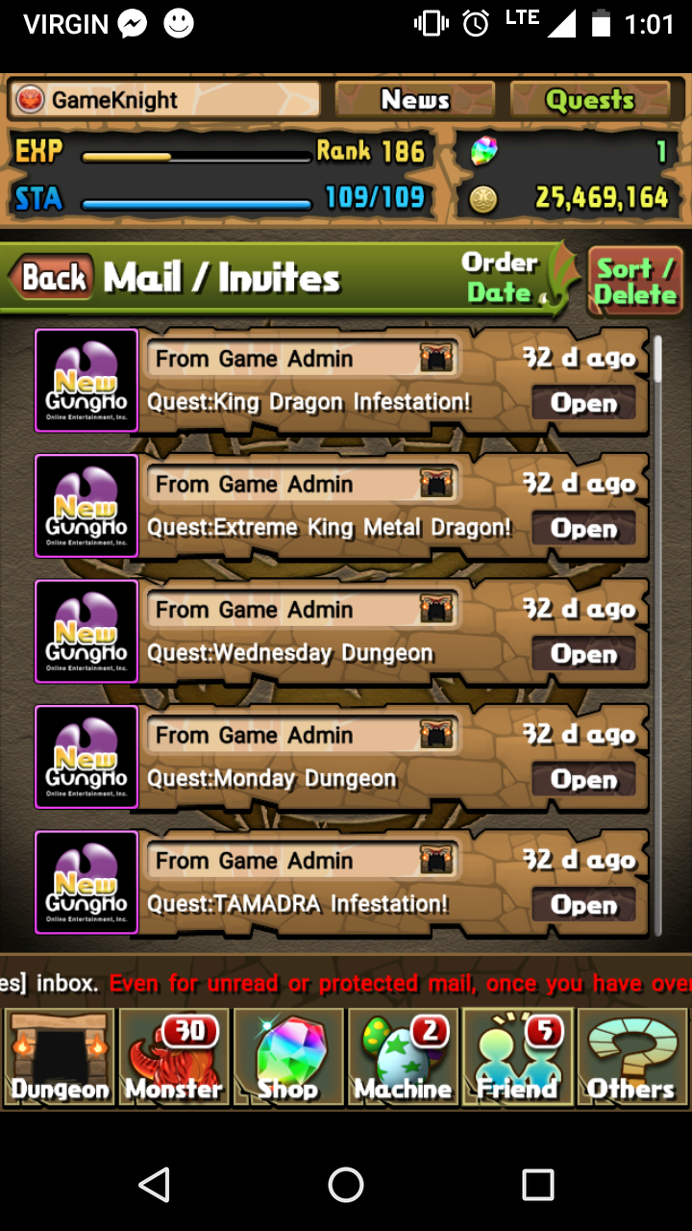Mail Screen**

This is a screen similar to what a player would see when they open their mailbox

* Tapping on “Open” will allow you to view the contents of the mail

Figure 38 Mailbox

**Mail**

This is the screen displayed upon opening a piece of mail.

* Delete- Removes this mail from your mailbox
* \*Protect – Opts this mail out of “Delete All Read Mail” feature

Figure 39 Piece of mail



**Dungeon Mail**

This is mail that will give you access to a certain dungeon with a set length of time for availability.

* Begin – This activates the dungeon for use
* Back – Returns you to the previous screen

Figure 40 Dungeon Mail



**Mail Sorting / Deleting**

These are the various options and ways you can sort mail as well as where you can delete all mail simultaneously with one exception\*

* Date – Sorts mail by date received in descending order
* Type – Sorts mail by the different types
* Time Left – Sorts mail based on time before expiry
* Invites – Displays all the friend invites in your mail

Figure 41 Mail Sorting

**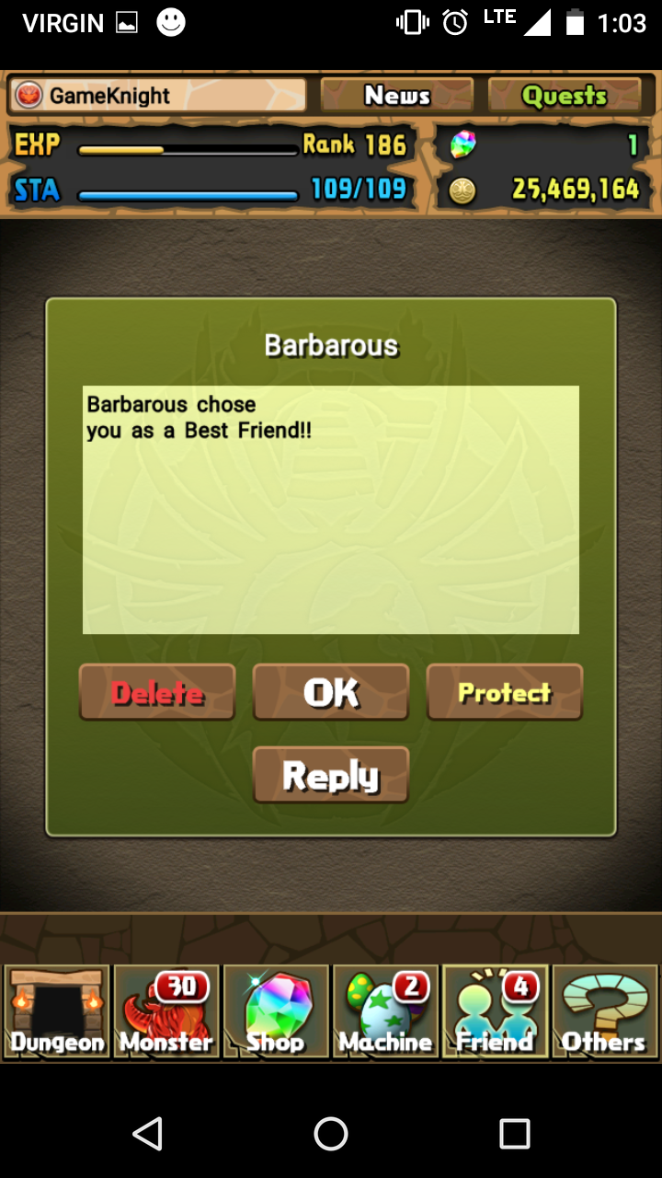Best Friend Mail**

This is a mail message received in your mailbox when someone chooses you as a best friend

* Delete – Removes this mail from your inbox
* Ok – Returns you to the previous screen
* Reply – This feature only shows up on mail from other players and allows you to send a message to them

Figure 42 Best Friend



**Mail Expiry**

This displays how many days an unclaimed piece of mail has before it expires. When this expires it will become unclaimable

Figure 43 Mail Expiry

### Friends

Friends are players that have either accept a friend request from you or that you have accepted friend requests from. You can use their leaders as helpers in dungeons to get bonuses.

#### Gaining Friends

* Accepting a friend request
* Sending a friend request to a non-friend helper
* Sending a friend request to a specific player ID

#### Friend Types

* Non-Friends
  + Players not on your Friend List
  + Labeled as User in Select a Helper screen
  + Given a chance to send a friend request after successfully completing a dungeon using their leader as a helper

Figure 44 Select a Helper Screen

* + Can only access their current leader
  + Gain 5 Pal points after successfully completing a dungeon using their leader as a helper and vice versa
* Friends
  + Players found in Friend List
  + Labeled as Friend in Select a Helper screen
  + Can access their first and current leader and vice versa
  + Gain 10 Pal points after successfully completing a dungeon using one of their leader as a helper and vice versa
  + Can only use each leader once every time they log in
  + Friend must log in daily for their leaders to be selectable
* Best Friends
  + Listed as best friend in Friend List
  + Labeled as Best Friend in Select a Helper screen
  + Can access their first, second, and current leader and vice versa
  + Gain 100 Pal after successfully completing a dungeon using one of their leader as a helper and vice versa
  + Unlocks a best friend selection at rank 50
  + Best friend status’ are two ways, meaning if one friend upgrades a friend to a best friend, both player have the best friend status for each other
  + Friend must log in daily for their leaders to be selectable
  + Best friend’s leaders are available all day no matter how many times they are used so long as the best friend has logged in within the day

#### Friend List

The friend list is used to view all of your current friends with their current team’s leader. Here you can choose to (See Figure 17 & 18):

* Add to Favorite – Gives a friend a favorite status, preventing you from deleting that friend as well as making them easier to find in both the Friend List and Select a Helper screens
* Check Info – Displays the information of the friend’s current leader
* Delete – Removes that friend from your friend list, does not appear if friend is favorited
* Remove from Fav. – Removes the favorite status from a friend, allowing you to once again delete them from your Friend List (Only appears if that friend is favorited)

**Note:** If a best friend is either deleted or deletes you, they will no longer have a best friend status if they are re-added. You also will not get back the best friend status to place on another friend.

Player starts off with 20 friend slots and gains more while ranking up, up to 50 slots.

Friend slots can be purchased with magic stones, 1 stone unlocks 5 friend slots.

Figure 46 Friend List Screen



Figure 47: Friend Options, Not Favorited(Left), Favourited(Right)

### Game Currency

Currently there are 4 types of currencies, Coins, Pal Points, Monster Points, and Magic Stones.

#### Coins

Figure 48: Magic Stones and Coins (Right Side)

Coins are the most common and most used currency in puzzle and dragons.

Coins are used for:

* Power-Up Fusion
* Evolution
* Assists
* Purchasing Coin Dungeons

Ways of receiving coins

* Successfully completing dungeons
* Rewards from quests
* Rewards from challenge dungeons
* Selling monsters
* Daily login bonus

#### Pal Points

Figure 49: Pal Points

Pal points are used for the Pal Egg Machine.

Ways of Receiving Pal Points

* Choosing a Helper
* Chosen as a Helper
* Completing a dungeon in multiplayer
* Daily login bonus
* Rewards from quests
* Rewards from challenge dungeons

#### Monster Points

Figure 50: Monster Points

Monster points are used to purchase monsters from the Purchase Monster store.

Ways of Receiving Monster Points

* Selling a monster provides a set amount of monster points based on the specific monster.
* Completing dungeons in multiplayer
* Rewards from completing certain dungeons

#### Magic Stones

Magic stones are used for:

* Rare/Event Egg Machines
* Restoring Stamina
* Increasing Monster Box Capacity
* Increasing Friend List Capacity
* Continuing a dungeon you died in

Ways of Receiving Magic Stones

* Completing Dungeons
* Purchasing them with real life currency
* Rewards from Admins
* Rewards from quests

### Egg Machines

Egg machines are a special feature of the game that will give you monsters for a certain price. There are 3 types of egg machines currently in Puzzle and Dragons and they are as follows:

* PAL Egg Machine
  + The egg machine that you spend PAL points on to receive monsters
* Rare Egg Machine
  + An egg machine that you spend magic stones on to receive monsters
* Event Egg Machine
  + Egg machine that pertains to specific events that happen throughout the year

#### Egg Machine Modifiers

This is the current list of egg machine modifiers

* Events
  + If there is a special limited time event there will be drops based on that event
* Galas
  + There will be periods of time where monsters of certain primary attributes will have a higher chance of dropping
* PAL Rotation
  + The PAL egg machine has a rotation of different monsters that can drop from it ranging from monsters used for evolving to rare monsters
* Bonus Monsters
  + Sometimes an egg machine will offer you an extra monster for pulling from it
* Increased rates
  + Sometimes specific monsters will have a higher chance of dropping from an egg machine

#### Egg Machine Costs

Each egg machine requires you to feed it currency before it will give you a monster egg the currency is dependent on the machine and the cost (currently only for the event egg machine) may vary

* Pal Egg Machine
  + Currency – PAL points
  + Current Price – 500 PAL points
* Rare Egg Machine
  + Currency – Magic stones
  + Current Price – 5 magic stones
* Event Egg Machine
  + Currency – Magic stones
  + Current Prices – 5 or 10 Magic stones

#### Event Egg Machine Types

Event egg machines are one of the communities’ favorite egg machines as they can offer unique and rather powerful monsters. These egg machines can come in a few different types

* Holidays
  + Sometimes through the year there will be a holiday egg machine these will drop monsters associated to these holidays
* Series
  + Through the year Gungho will release updates to certain monster series’ that they deem necessary for their own egg machines
* Collaborations
  + On occasion Gungho will team up with another company whether it be a game company or an anime company in order to release monsters from content produced by the partner company for example Final Fantasy Collaboration

## Requirements Fundamentals

## Practical Considerations

## Requirement Information Items

# Processes

#### Selling Monsters

Monsters a player owns can be sold if the player so chooses. Selling a monster removes that monster from the player’s roster and the player is given coins and Monster Points in return. The value of each currency will be determined by the monster and by the monster’s current stats, Active Skill level and Awoken Skills unlocked.

## Requirements Processes

## Stakeholder Requirements Definition Process

## Requirements Analysis Process

## Requirements Engineering Activities in Other Technical Process

## Requirements Management

# Information Items

# Guidelines for Information Items

# Information Item Content